EXPERIMENT – 23.

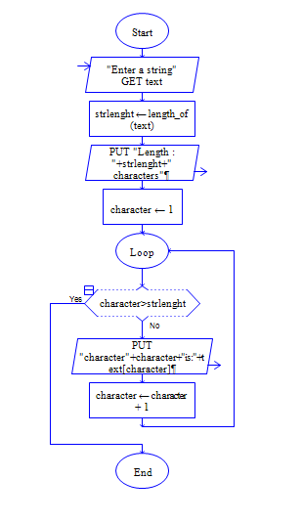

Output:

